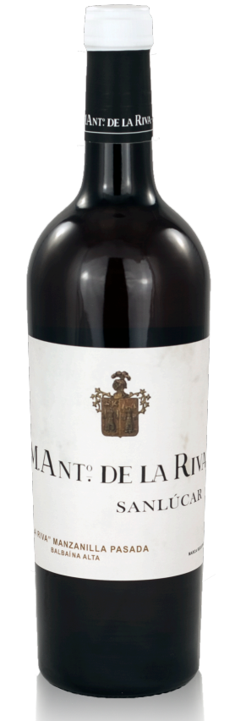
Origin
Jerez, Andalucía, Spain.
Varieties
100% Palomino Fino.
Vineyard
From a parcel in the Balbaina pago that was uprooted in 2012 (after the owner’s last harvest). The vines were roughly 45 years old, and the soils were Tosca Cerrada albariza. Balbaina is the closest of the famous pagos to the Atlantic, and its wines tend towards delicacy.
Vinification Method
From an old solera of 20 botas that was last replenished in 2012, when the former owners carried out their final harvest. Resting and aging biologically since, the alcohol content and concentration has increased, and the average age of the wine is 15-18 years. The 7 most characterful botas were used for this bottling; the remainder will continue to develop into amontillado.
Properties
Alcohol: 15.85%
Total acidity: 3.9
Bottles Made: 2,500 bottled in May 2019
Producer Profile
Renowned winemakers Willy Pérez & Ramiro Ibañez set out with the goal of connecting old soleras to their vineyards and have done just that with the revival of the M. Antonio de la Riva label for their project. In the early 20th century, the historic bodega was well known throughout the region and Bodegas de la Riva held 53 hectares in Pago Macharnudo, one of Jerez’s most famous pagos. In the early ‘70s, M.A. de la Riva was sold to Domecq, who slowly dissolved the brand. When Willy and Ramiro were recently able to purchase a few rows in the Pago Macharnudo they decided to revive the long-admired De La Riva name in honor of its connection to the storied Macharnudo vineyard and in tribute to the traditional wines of its past. Ramiro and Willy, with inspiration from this ancient estate want to remake the reputation of contemporary sherry, reorienting towards specific vineyards and soil types, rather than cellar procedures or processes – embracing the complexity of Sherry’s past, and reinterpreting its future. With these broad goals, Willy and Ramiro are open to bottling all kinds of traditionally made wines from El Marco de Jerez under the M.A. de la Riva label.

