Origin
Hervededo, Bierzo, Galicia.
Varieties
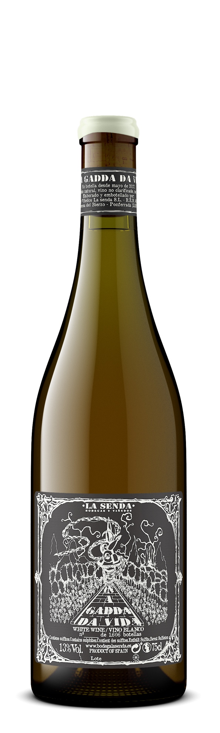
100% Godello.
Vineyard
From a 80-95-year-old parcel “Los Campos” situated amongst woods and wild nature, at 500-550 meters on the eastern side of Bierzo. Soils are clay-calcareous with trace minerals.
Vinification Method
Grapes were hand-harvested and partially destemmed, macerate on their skins for 90 days in a mix of French oak and chestnut barrels. The wine is racked off the skins, and fermentation completes in the same vessels. The wine rests 5 months in a mix of used French and Slovenian oak barrels. Bottled without fining, filtering, or sulfur addition.
Properties
No Added SO2.

Producer Profile
Diego Losada is a Bierzo native who, after working at a couple bigger wineries, struck out on his own with his project La Senda (meaning “the path” or “the way”) in 2013. He works organically with just over 5 hectares of 60+ year old vineyards at elevations of over 600 feet, about 15 parcels in total. He looks for bush vine vineyards that are not easily accessible by road and planted on either clay-calcareous or slate soils since they are less likely to be exposed to chemical treatments. In the winery, Diego works with a mix of unlined concrete vats and older oak & chestnut casks and foudre with no pumps or SO2 additions. The Bierzo appellation is at the northwest corner of Castilla y León, bordering Galicia. The rolling hills are full of abandoned gold, iron and magnesium mines from centuries past.

